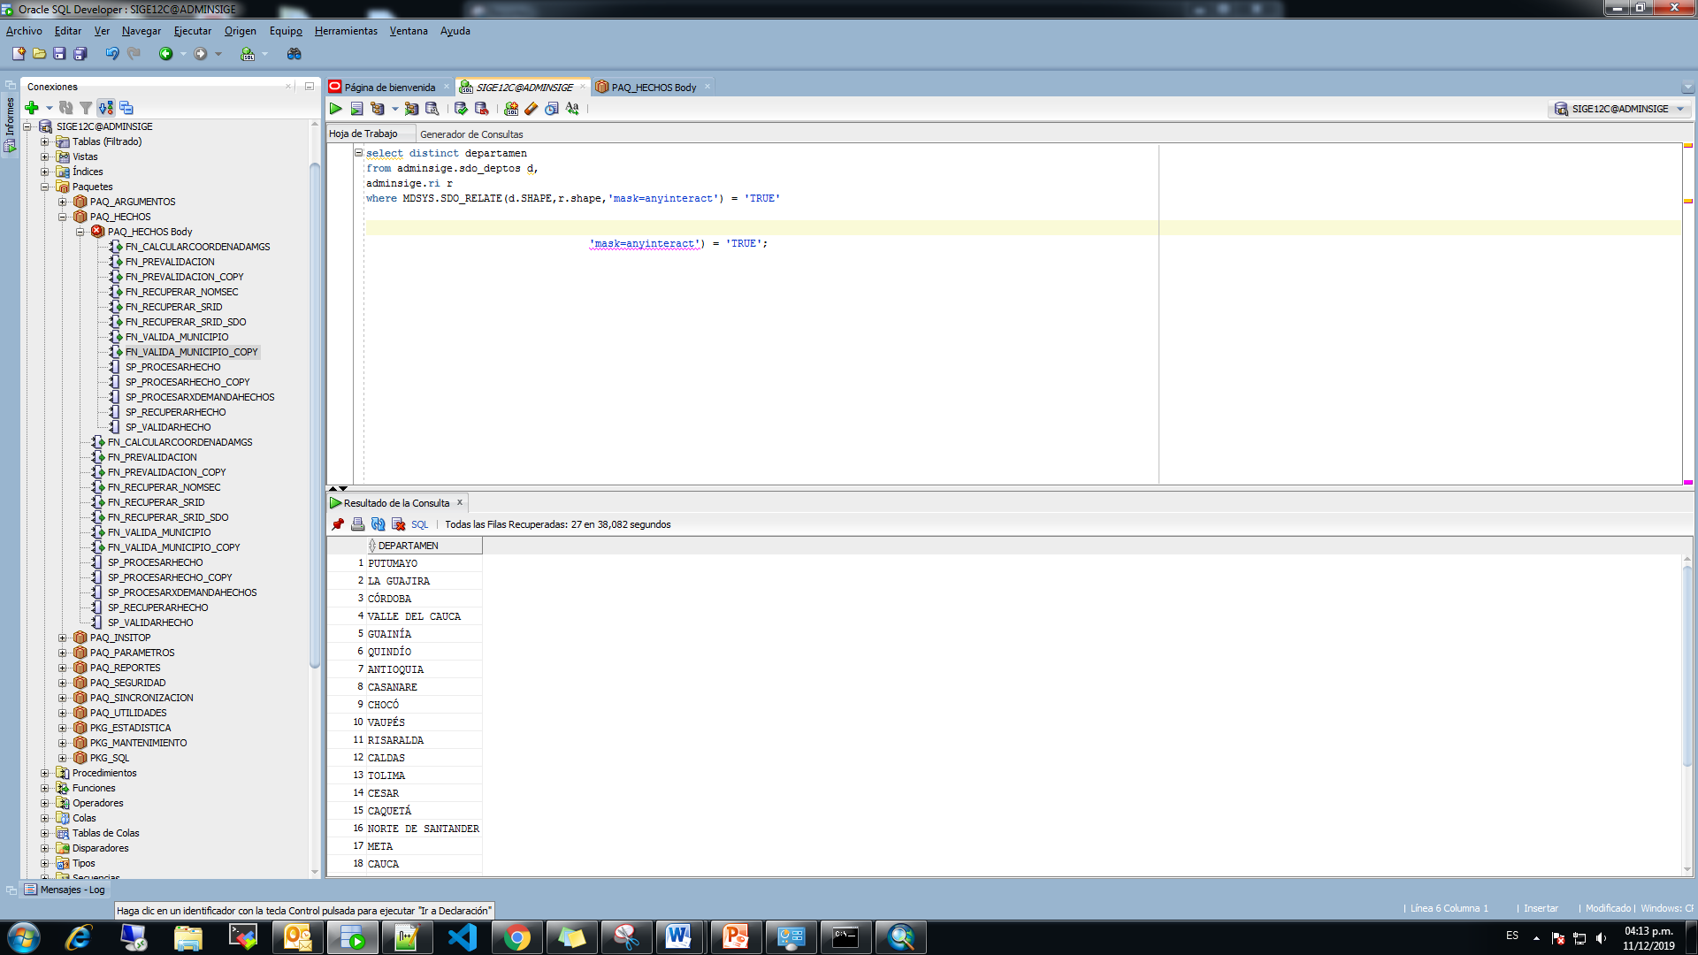

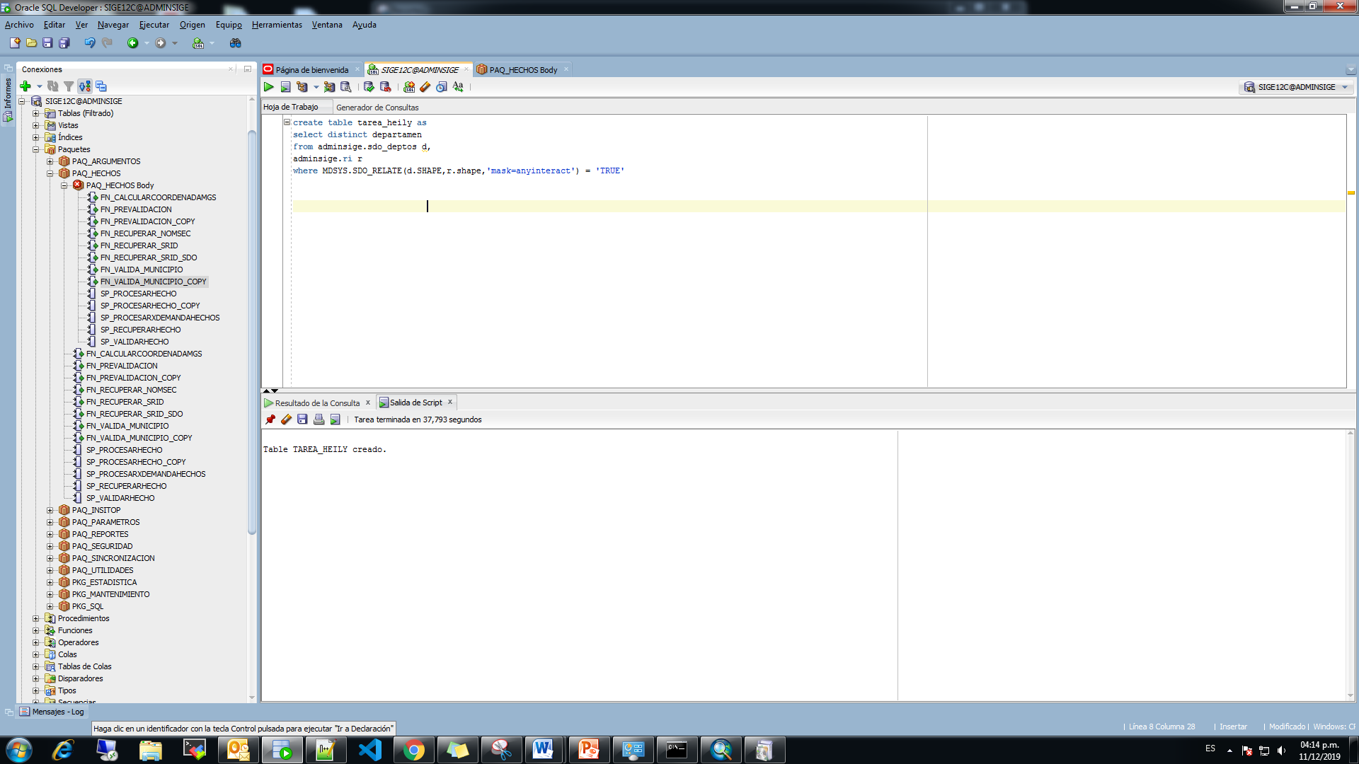

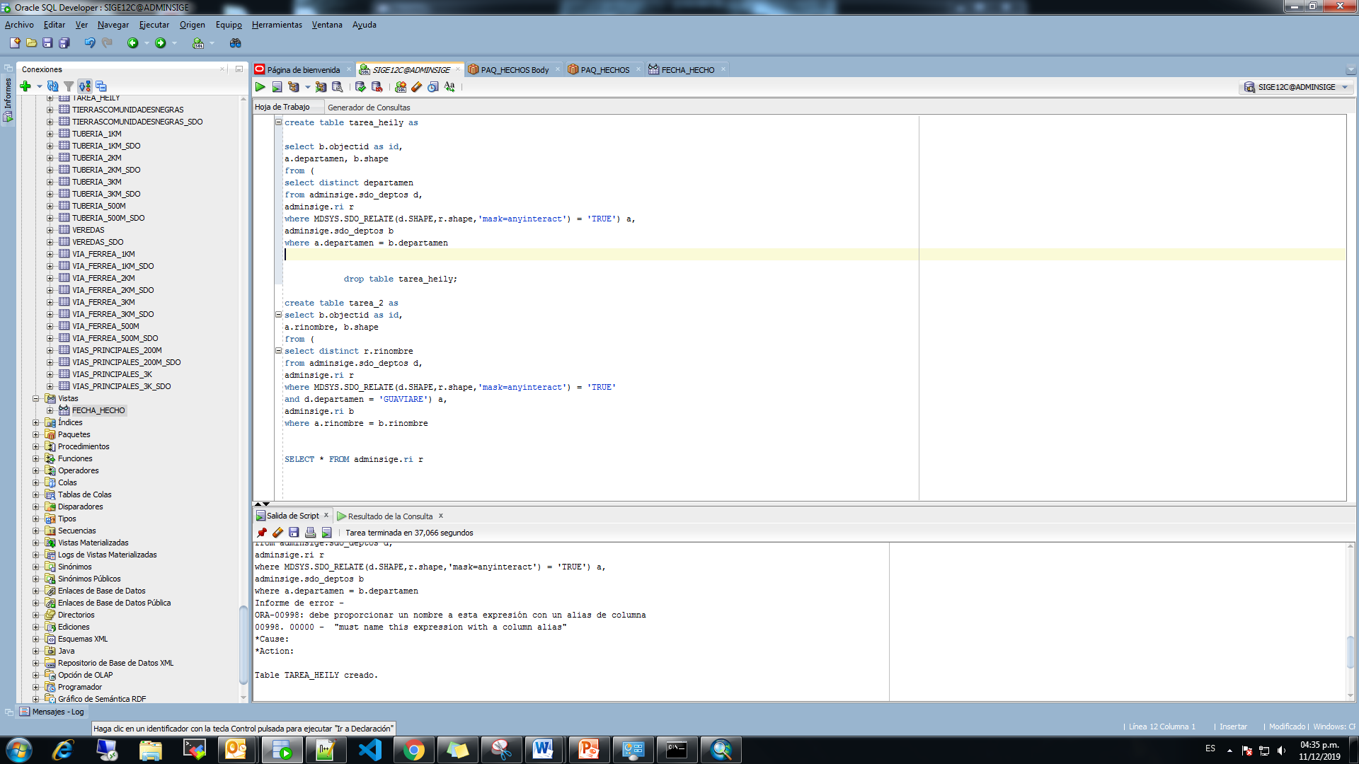

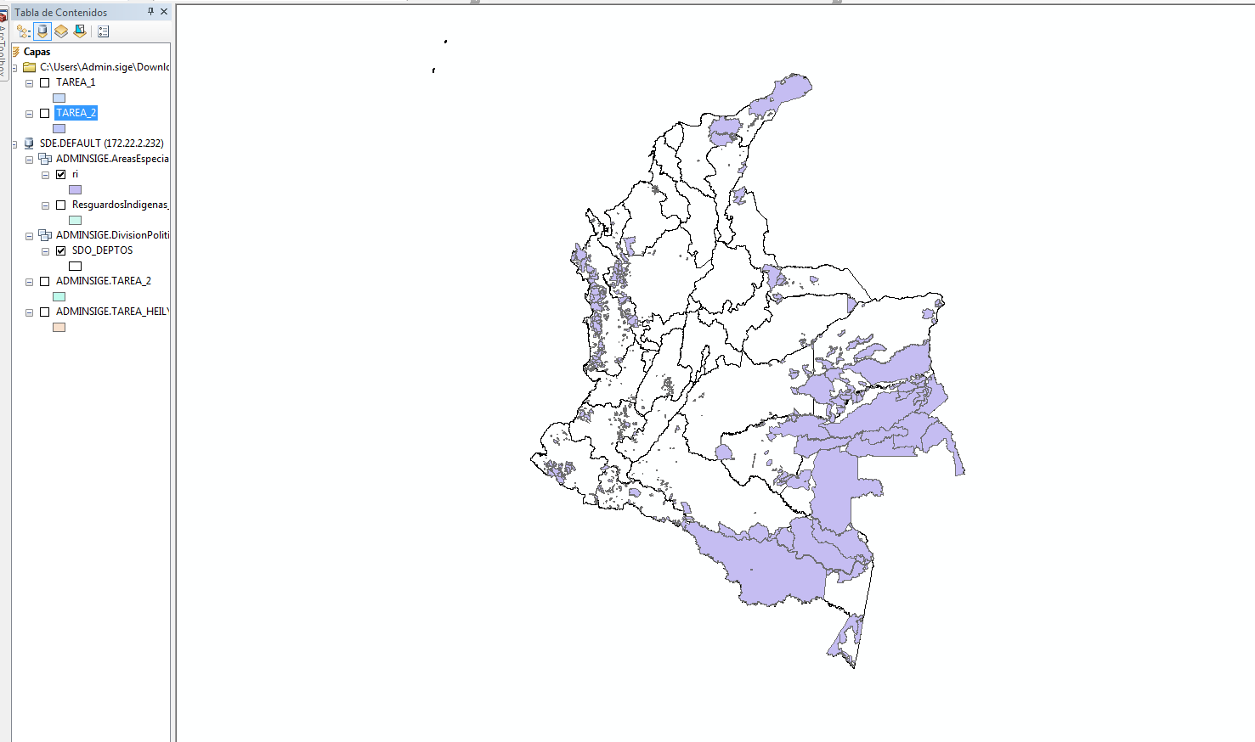

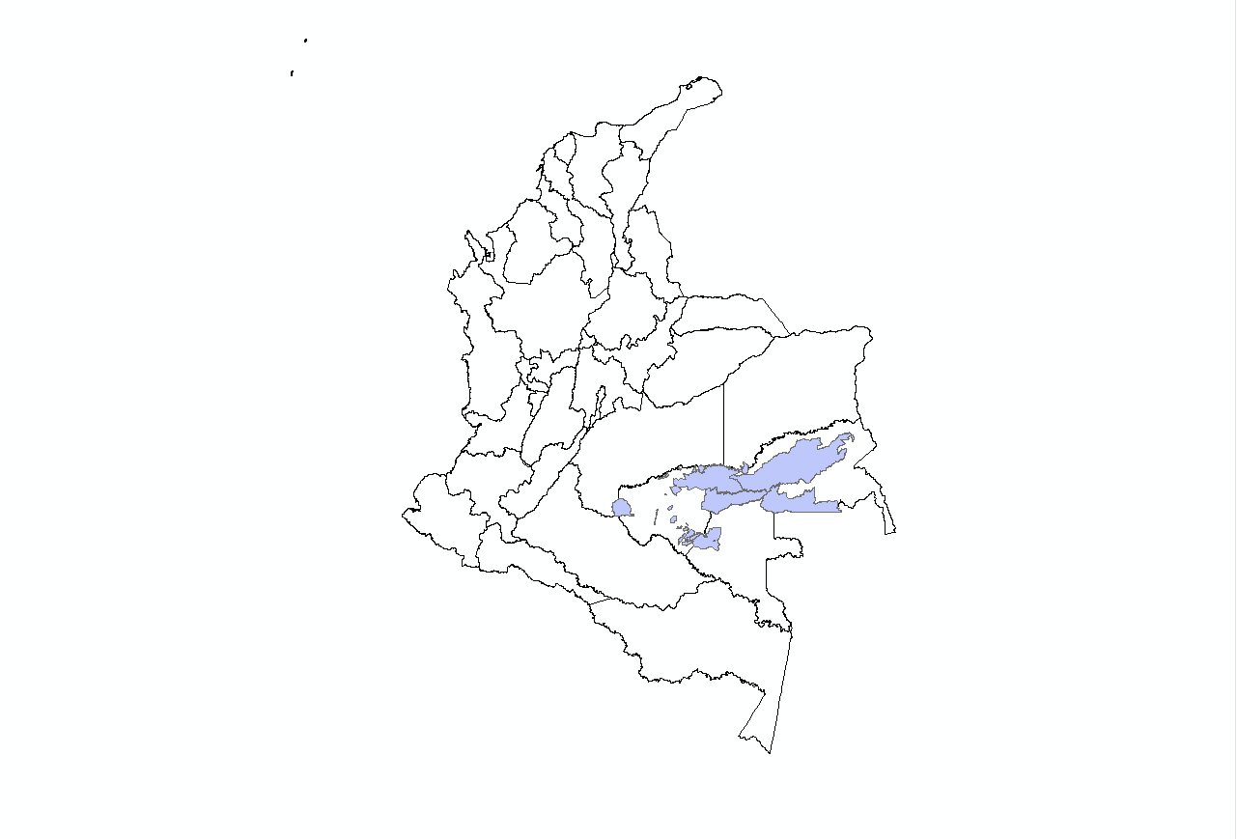

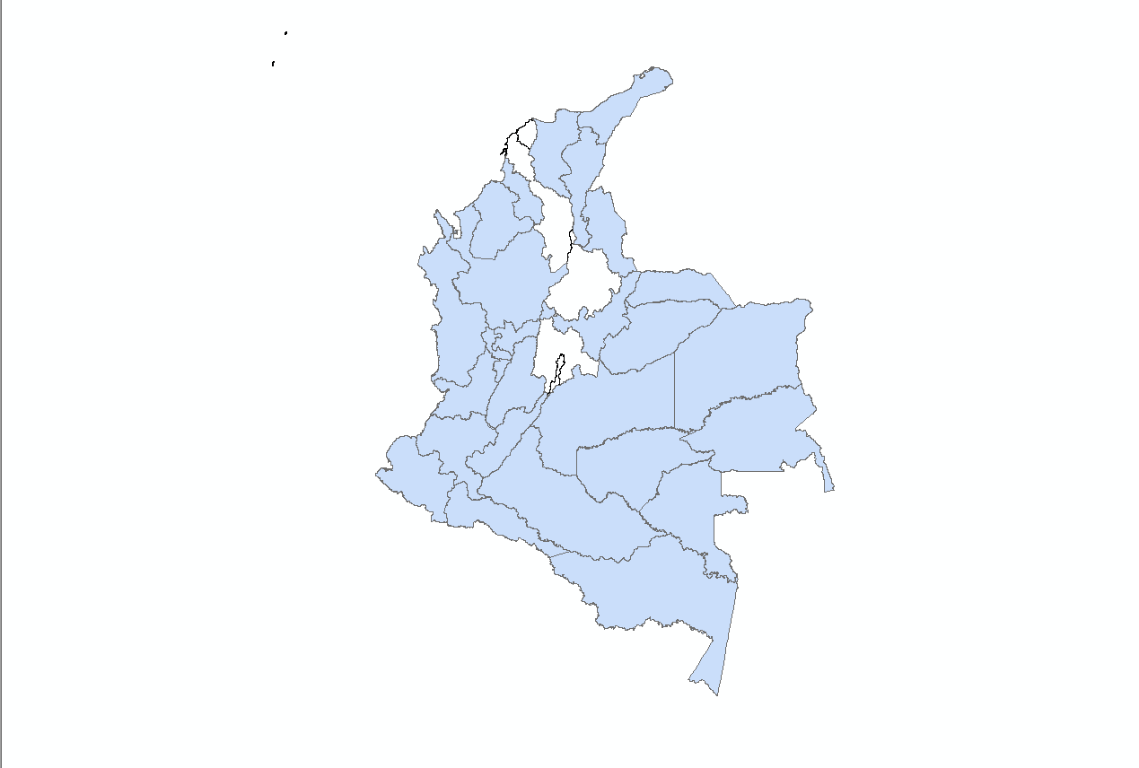

**CÓDIGO SQL**

create table tarea_heily as

select b.objectid as id,

a.departamen, b.shape

from (

select distinct departamen

from adminsige.sdo_deptos d,

adminsige.ri r

where MDSYS.SDO_RELATE(d.SHAPE,r.shape,'mask=anyinteract') = 'TRUE') a,

adminsige.sdo_deptos b

where a.departamen = b.departamen

create table tarea_2 as

select b.objectid as id,

a.rinombre, b.shape

from (

select distinct r.rinombre

from adminsige.sdo_deptos d,

adminsige.ri r

where MDSYS.SDO_RELATE(d.SHAPE,r.shape,'mask=anyinteract') = 'TRUE'

and d.departamen = 'GUAVIARE') a,

adminsige.ri b

where a.rinombre = b.rinombre